Vision
Revision History
Version | Date | Description | Author
inception draft | Jan 10, 2031 | First draft. To be refined primarily during elaboration. | Craig Larman

Introduction
We envision a next generation fault-tolerant point-of-sale (POS) application, NextGen POS, with the flexibility to support varying customer business rules, multiple terminal and user interface mechanisms, and integration with multiple third-party supporting systems.
Positioning
Business Opportunity
Existing POS products are not adaptable to the customer's business, in terms of varying business rules and varying network designs (for example, thin client or not; 2, 3, or 4-tier architectures). In addition, they do not scale well as terminals and business increase. And, none can work in either on-line or off-line mode, dynamically adapting depending on failures. None easily integrate with many third-party systems. None allow for new terminal technologies such as mobile PDAs. There is marketplace dissatisfaction with this inflexible state of affairs, and demand for a POS that rectifies this.
Problem Statement
Traditional POS systems are inflexible, fault intolerant, and difficult to integrate with third-party systems. This leads to problems in timely sales processing, instituting improved processes that don't match the software, and accurate and timely accounting and inventory data to support measurement and planning, among other concerns. This affects cashiers, store managers, system administrators, and corporate management.
Product Position Statement
Terse summary of who the system is for, its outstanding features, and what differentiates it from the competition.
Alternatives and Competition...
Stakeholder Descriptions
Market Demographics...
Stakeholder (Non-User) Summary...
User Summary...
Key High-Level Goals and Problems of the Stakeholders
A one-day requirements workshop with subject matter experts and other stakeholders, and surveys at several retail outlets led to identification of the following key goals and problems:
High-Level Goal | Priority | Problems and Concerns | Current Solutions
Fast, robust, integrated sales processing | high | Reduced speed as load increases.  Loss of sales processing capability if components fail.  Lack of up-to-date and accurate information from accounting and other systems due to non-integration with existing accounting, inventory, and HR systems. Leads to difficulties in measuring and planning.  Inability to customize business rules to unique business requirements.  Difficulty in adding new terminal or user interface types (for example, mobile PDAs). | Existing POS products provide basic sales processing, but do not address these problems.
. . . | . . . | . . . | . . .

User-Level Goals
The users (and external systems) need a system to fulfill these goals:
- Cashier: process sales, handle returns, cash in, cash out
- System administrator: manage users, manage security, manage system tables
- Manager: start up, shut down
- Sales activity system: analyze sales data
- …
User Environment…

Product Overview
Product Perspective
The NextGen POS will usually reside in stores; if mobile terminals are used, they will be in close proximity to the store network, either inside or close outside. It will provide services to users, and collaborate with other systems, as indicated in Figure Vision-1.

Figure vision- 1. NextGen POS system context diagram
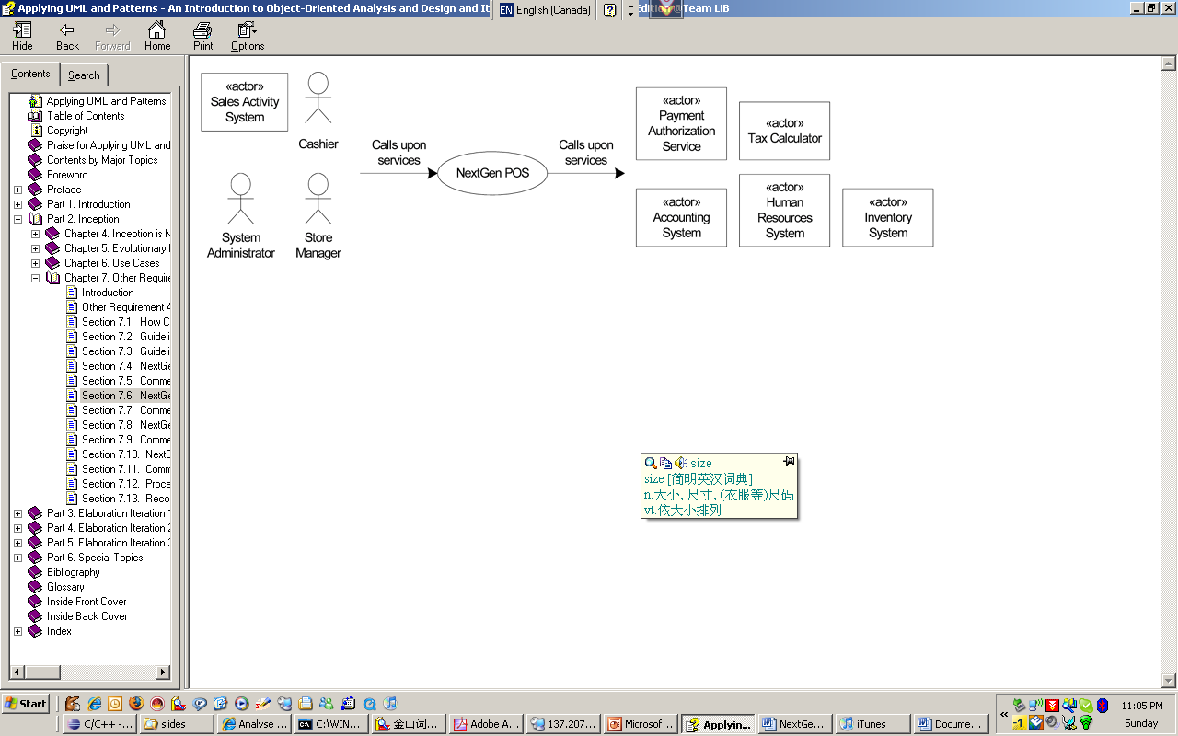
Summary of Benefits
Supporting Feature | Stakeholder Benefit
Functionally, the system will provide all the common services a sales organization requires, including sales capture, payment authorization, return handling, and so forth. | Automated, fast point-of-sale services.
Automatic detection of failures, switching to local offline processing for unavailable services. | Continued sales processing when external components fail.
Pluggable business rules at various scenario points during sales processing. | Flexible business logic configuration.
Real-time transactions with third-party systems, using industry standard protocols. | Timely, accurate sales, accounting, and inventory information, to support measuring and planning.
. . . | . . .
Assumptions and Dependencies...
Cost and Pricing...
Licensing and Installation...
Summary of System Features
- sales capture
- payment authorization (credit, debit, check)
- system administration for users, security, code and constants tables, and so forth.
- automatic offline sales processing when external components fail
- real-time transactions, based on industry standards, with third-party systems, including inventory, accounting, human resources, tax calculators, and payment authorization services
- definition and execution of customized "pluggable" business rules at fixed, common points in the processing scenarios
- …
Other Requirements and Constraints
Including design constraints, usability, reliability, performance, supportability, design constraints, documentation, packaging, and so forth: See the Supplementary Specification and use cases.

